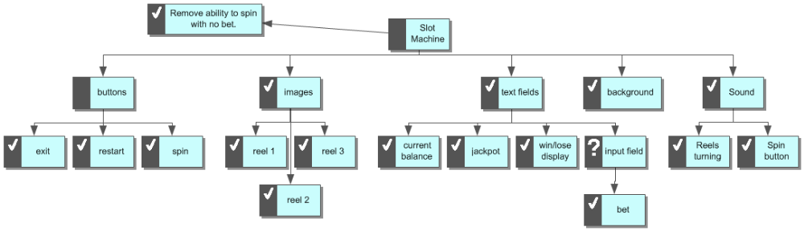

Slot Machine
I. background
II. text fields
A. current balance
B. input field
1. bet
C. jackpot
D. win/lose display
III. buttons
A. exit
B. restart
C. spin
IV. Sound
A. Reels turning
B. Spin button
V. images
A. reel 1
B. reel 3
C. reel 2
VI. Remove ability to spin with no bet.

